1. **Create customer table which comprises of columns : customer_id ,first_name, last_name, email, address, city, state, zip**

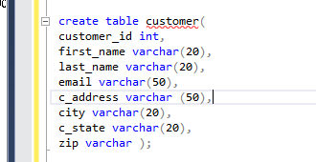



1. **Insert 5 rows**

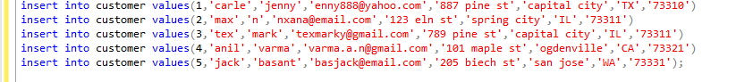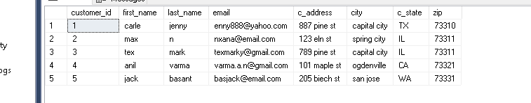

1. **Select first name and last name columns from customer table** 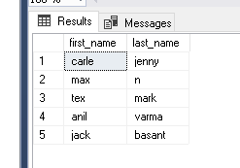
2. **Select records where first name starts with ‘g’ and city is San Jose**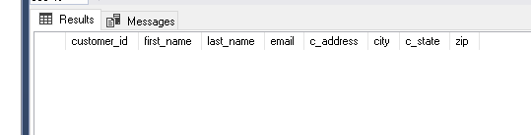
3. **Select records where email has only gmail**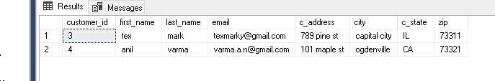

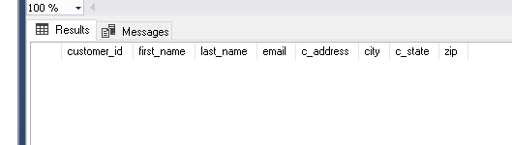

1. **Select records where last name doesn’t end with a**

**select* from customer where last_name not like ‘a%’;**